FitBuddy – AI Fitness Plan Generator
Project Documentation
AI-Powered Personalized Fitness Planning Web Application
Technology Stack
FastAPI • Google Gemini • SQLAlchemy • SQLite • Jinja2 • HTML/CSS
A practical demonstration of Generative AI, web development, database integration, and user-centered design.

Project Description
FitBuddy is a web-based AI fitness planning application designed to generate personalized, structured workout guidance from a user's fitness profile. The application combines a FastAPI backend, a clean Jinja2-rendered interface, SQLAlchemy with SQLite for persistence, and Google's Gemini generative AI services.
The user enters essential information such as User ID, name, age, body weight, fitness goal, and preferred workout intensity. FitBuddy processes these inputs and produces a personalized 7-day workout plan together with a concise nutrition or recovery tip. The generated plan is presented through an easy-to-read results page so that the user can immediately understand and follow the recommended routine.
A key strength of the project is its feedback-driven design. Users can describe changes they would like to make—for example, adding cardio, reducing training volume, or including more flexibility work—and the application uses the existing plan and the user's feedback to create an updated version. This makes the application more interactive than a one-time plan generator.
Project Objectives
- Build a practical AI-powered fitness planning web application.
- Demonstrate integration of a modern Generative AI API with a Python web framework.
- Generate structured and personalized 7-day workout plans.
- Provide concise nutrition and recovery guidance aligned with the user's goal.
- Allow users to refine plans through natural-language feedback.
- Persist user and plan information using SQLite and SQLAlchemy.
- Provide a clean, accessible interface suitable for a real-world application concept.

Project Scenarios
Scenario 1 – Personalized Plan Generation
A user enters their profile, selects a fitness goal such as muscle gain, weight loss, or general wellness, and chooses a workout intensity. FitBuddy generates a goal-oriented 7-day plan with structured exercise guidance.
Scenario 2 – AI-Based Plan Refinement
A user reviews the generated plan and submits feedback describing what they want changed. FitBuddy uses the original plan together with the feedback to produce an improved version.
Scenario 3 – Nutrition and Recovery Support
The application provides a concise nutrition or healthy-lifestyle tip related to the user's goal and workout intensity, complementing the exercise plan with practical recovery guidance.
Scenario 4 – Administrative User View
An administrator or coach can access the user view to review stored user records and generated plans. This demonstrates how the application can support oversight and future coaching workflows.

Technical Architecture
FitBuddy follows a modular web-application architecture. The browser provides the user interface, FastAPI handles HTTP requests and application routing, Jinja2 renders dynamic HTML pages, SQLAlchemy manages database operations, SQLite stores user and plan data, and the Gemini API provides generative AI capabilities.
Layer | Technology | Responsibility
Presentation Layer | HTML / CSS / Jinja2 | User forms, generated plan display, feedback interface and navigation.
Application Layer | FastAPI / Python | Routing, validation, request handling and coordination of services.
AI Layer | Google Gemini | Workout-plan generation, nutrition tips and feedback-based plan refinement.
Data Layer | SQLAlchemy / SQLite | Persistent storage of user information and generated plan data.
Server Layer | Uvicorn | Runs the FastAPI application locally as an ASGI server.
Application Flow
- User opens the FitBuddy home page.
- User enters profile information and selects a fitness goal and workout intensity.
- FastAPI receives and validates the submitted form.
- The application sends a carefully structured prompt to the configured Gemini model.
- Gemini returns personalized workout guidance and a practical nutrition/recovery tip.
- The result is rendered dynamically through Jinja2.
- User feedback can be submitted to refine the existing workout plan.
- Relevant user and plan information is persisted in SQLite through SQLAlchemy.

Pre-Requisites
- Python programming fundamentals.
- Basic FastAPI and REST/web application concepts.
- HTML and CSS fundamentals.
- Jinja2 template concepts.
- Basic SQLAlchemy and SQLite knowledge.
- Understanding of environment variables and API keys.
- Familiarity with virtual environments and pip.
- Basic understanding of Generative AI and prompt design.

Project Workflow

Milestone 1. Model Selection and Architecture
- Activity 1.1. Define AI requirements and select a suitable Gemini model
- Activity 1.2. Design the application architecture
- Activity 1.3. Configure the development environment and project settings
Milestone 2. Core Functionality Development
- Activity 2.1. Develop workout, nutrition and plan-update functionality
- Activity 2.2. Implement FastAPI request handling, validation and persistence

Milestone 3. Route and Application Logic
- Activity 3.1. Implement the main application logic and route coordination
- Activity 3.2. Connect AI generation, database operations and template rendering

Milestone 4. Frontend Development
- Activity 4.1. Design a clean, responsive user interface
- Activity 4.2. Create dynamic Jinja2 templates for forms, results and administration
Milestone 5. Deployment and Verification
- Activity 5.1. Prepare the application for local deployment
- Activity 5.2. Test the complete user journey and verify the implemented features

Milestone 1. Model Selection and Architecture
The first milestone established the technical direction of FitBuddy. The AI component needed to understand natural-language instructions, generate structured workout content, provide concise supporting advice, and respond efficiently enough for an interactive web experience.
Activity 1.1: Research and Select the Appropriate Generative AI Model
The current project uses Gemini 3.5 Flash-Lite for the workout-generation and nutrition-tip functions. The model is configured through environment variables so that the application remains flexible and can be adapted to future model requirements.
- Generate structured 7-day workout plans.
- Produce concise and practical nutrition or recovery tips.
- Use user feedback to improve an existing plan.
- Support natural-language prompts and formatted responses.
- Integrate cleanly with the Python application through the Google GenAI SDK.
Activity 1.2: Define the Application Architecture
The application was organized into separate configuration, database, AI-generation, routing, schema, template, and static-style components. This modular organization improves readability and makes individual parts easier to maintain and extend.
Activity 1.3: Set Up the Development Environment
- Created an isolated Python virtual environment.
- Configured project dependencies through requirements.txt.
- Stored configuration and API credentials in environment variables.
- Configured SQLite as the local development database.
- Prepared the FastAPI application for execution through Uvicorn.

Milestone 2. Core Functionalities Development
The core functionality was developed around the complete user journey: collecting profile information, generating an individualized plan, displaying supporting advice, storing relevant information, and allowing the user to refine the plan through feedback.
Activity 2.1: Develop the Core Functionalities
- Personalized 7-day workout generation.
- Goal- and intensity-aware AI prompting.
- Nutrition or recovery tip generation.
- Feedback-based workout plan refinement.
- Persistent user and plan information.
- Administrative view for stored users and plans.
Activity 2.2: Implement the FastAPI Backend
FastAPI acts as the central application layer. It receives form submissions, validates the incoming information, coordinates AI generation and database operations, and returns the appropriate Jinja2-rendered page.
Important application endpoints include:
- / – main FitBuddy interface
- /generate-workout – processes the fitness profile and generates the plan
- /submit-feedback – processes feedback and requests an updated plan
- /users – provides the administrative user view
- /docs – FastAPI interactive API documentation

Milestone 3. Route and Application Logic
Activity 3.1: Writing the Main Application Logic
The route layer connects the presentation, AI, and database components. It receives user input, invokes the appropriate generation function, stores the resulting information, and passes the required context to the Jinja2 templates.
Activity 3.2: AI Prompt Design and Service Integration
The AI prompts were designed to provide clear context about the user's profile and to guide Gemini toward practical, structured, and readable fitness content. Separate generation functions keep workout generation, nutrition advice, and plan updating logically organized.
The project uses environment-based configuration for the Gemini API key and model names. This keeps sensitive credentials outside the source code and allows model configuration to be changed without rewriting application logic.

Milestone 4. Frontend Development
Activity 4.1: Designing and Developing the User Interface
The interface was designed to feel modern, focused and approachable. The landing page clearly communicates the purpose of FitBuddy, while the plan-generation form keeps the number of required inputs manageable. Consistent spacing, cards, typography and navigation help users move through the application naturally.
Activity 4.2: Creating Dynamic Templates with FastAPI's Jinja2
- index.html – collects user information and starts plan generation.
- result.html – displays the user's profile, AI-generated workout plan and feedback controls.
- all_users.html – presents stored user information through the administrative view.
- style.css – provides the visual design system, spacing, typography, cards and form styling.
Activity 4.3: Implemented User Interface – Evidence
The following screenshots document the implemented application interface and demonstrate the complete visual workflow from the landing page through personalized plan generation and feedback-based adaptation.
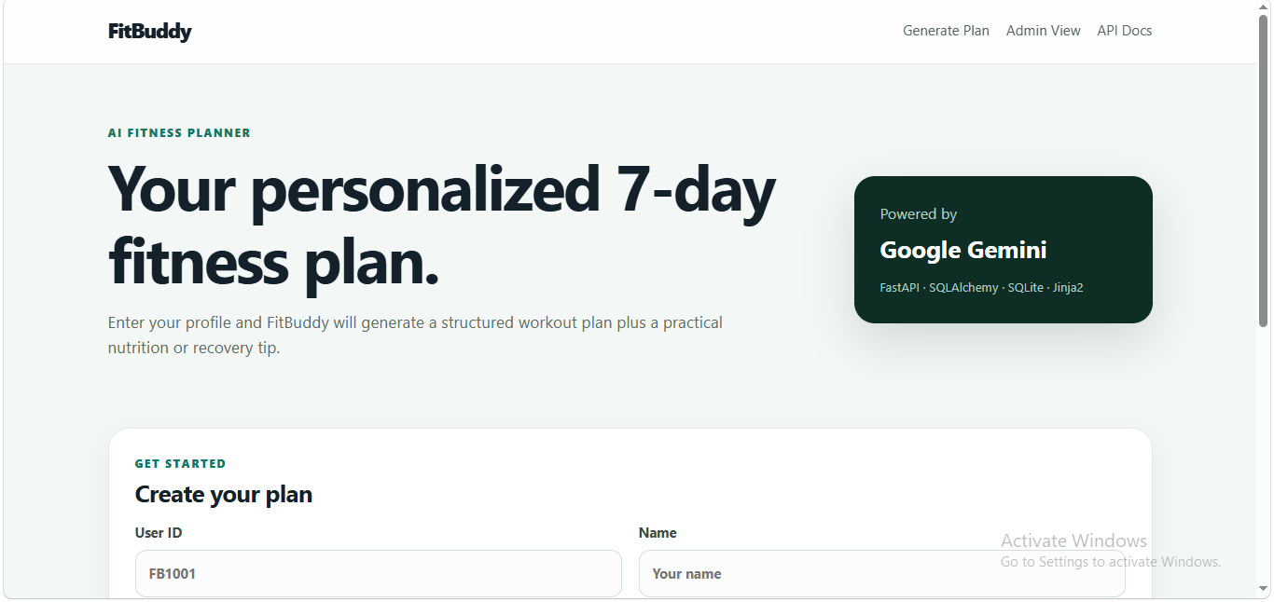
Figure 1. FitBuddy landing page with AI fitness planner introduction and technology overview.
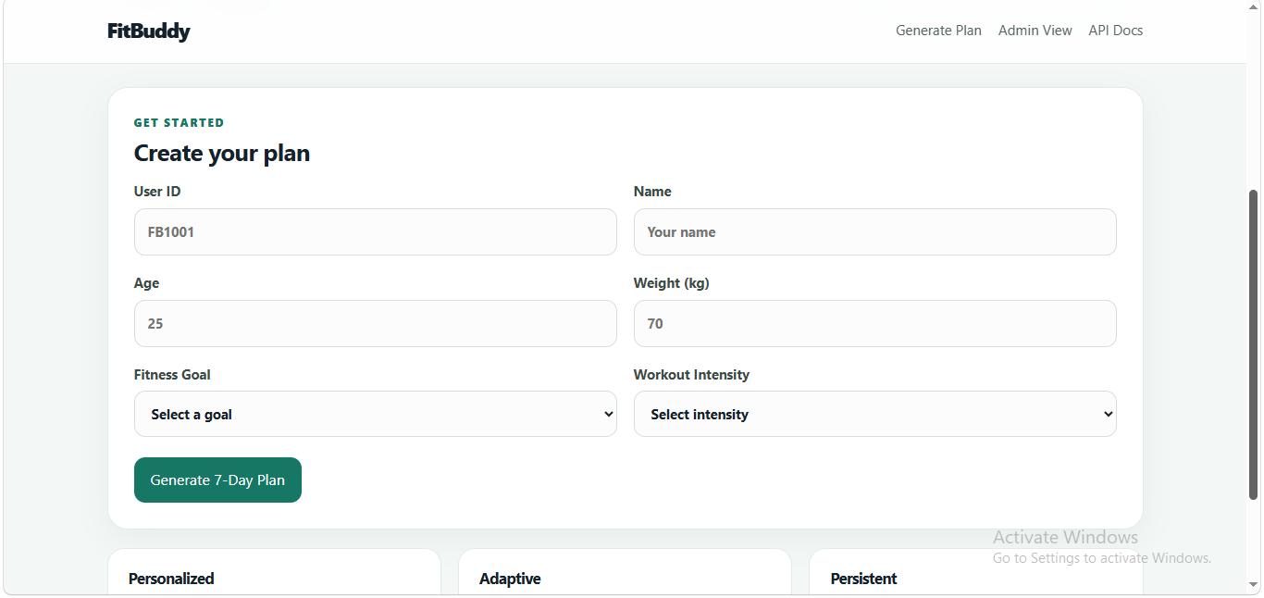
Figure 2. Plan creation form collecting User ID, name, age, weight, fitness goal and workout intensity.
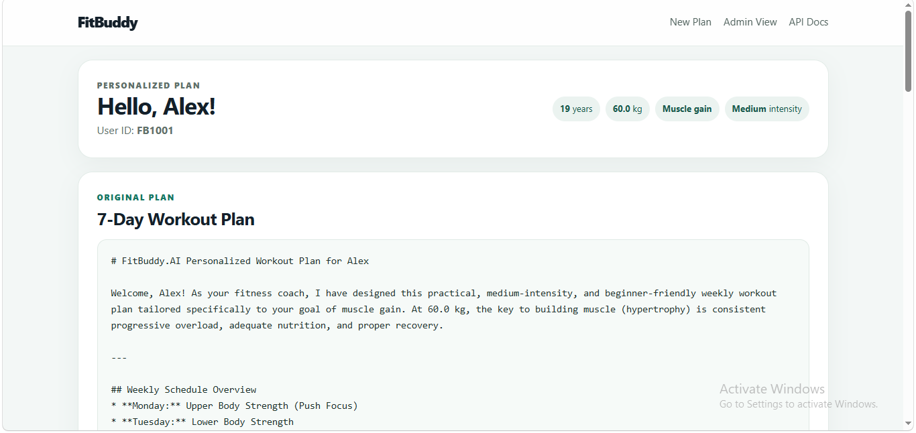
Figure 3. Personalized workout result page showing user profile information and AI-generated 7-day plan.
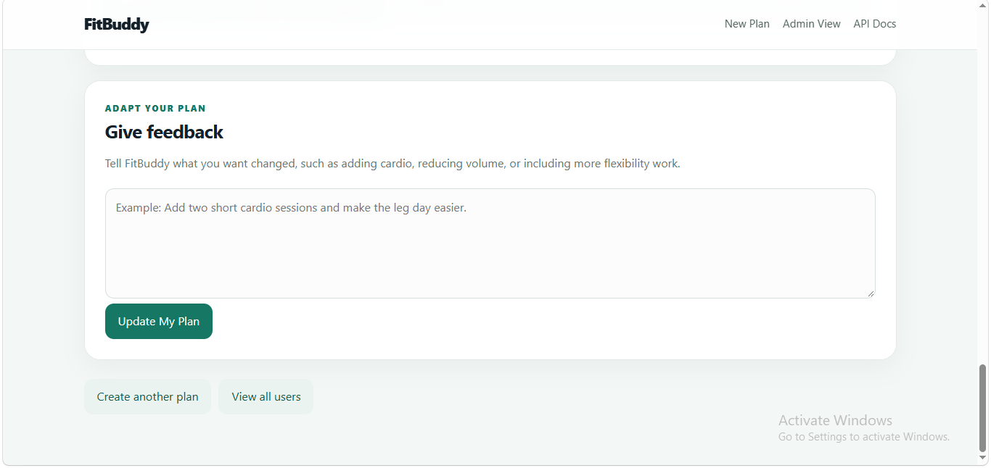
Figure 4. Feedback section allowing the user to request changes and adapt the generated plan.

Milestone 5. Deployment
Activity 5.1: Preparing the Application for Local Deployment
FitBuddy is designed to run locally using a Python virtual environment and Uvicorn. The application is configured through environment variables, and its dependencies are maintained in requirements.txt.
Typical local setup sequence:
- Create and activate the virtual environment.
- Install the project dependencies from requirements.txt.
- Configure the Gemini API key and model settings in .env.
- Start the application with Uvicorn.
- Open the application in a web browser at http://127.0.0.1:8000.
- Use FastAPI's interactive documentation at http://127.0.0.1:8000/docs when required.
Activity 5.2: Testing and Verifying Local Deployment
The implemented application was verified through the complete browser workflow. The home page loads successfully, the user form accepts the required profile information, the AI generation flow produces a personalized plan, and the result page provides an interface for further feedback and plan refinement.
- Verified the main user interface and navigation.
- Verified user profile input and form submission.
- Verified AI-generated workout plan presentation.
- Verified personalized goal and intensity information on the result page.
- Verified the feedback interface for adaptive plan generation.
- Verified the local FastAPI server and interactive API documentation.

Core Functionalities
Feature | Description | Value to the User
Personalized Workout Generation | Creates a structured 7-day plan from profile, goal and intensity inputs. | Reduces the effort required to design a starting routine.
Nutrition / Recovery Tip | Generates a concise goal-aligned healthy-lifestyle recommendation. | Complements physical training with practical supporting guidance.
Adaptive Feedback | Uses the existing plan and natural-language feedback to produce an improved version. | Makes the experience interactive and user-centered.
Persistent Storage | Stores user and plan information using SQLAlchemy and SQLite. | Provides continuity and supports administrative review.
Admin View | Displays stored users and their plan information. | Demonstrates a foundation for coach or administrator workflows.
Interactive API Docs | Exposes FastAPI's automatically generated documentation. | Makes the backend easier to inspect and demonstrate.

Learning Outcomes Demonstrated by the Project
FitBuddy demonstrates a broad set of practical software-development skills. The project is valuable not only because it produces an AI-generated result, but because it shows how several technologies can be combined into one coherent application.
- Generative AI integration – connecting a real web application to a Gemini model through the Google GenAI SDK.
- Prompt engineering – structuring prompts so that user information is translated into useful, goal-oriented responses.
- Backend development – implementing FastAPI routes, request handling and application logic.
- Frontend development – building a clean interface with HTML, CSS and Jinja2.
- Database development – using SQLAlchemy and SQLite for persistence.
- Configuration management – separating environment-specific settings and credentials from application code.
- Software architecture – organizing the project into maintainable modules.
- User-centered design – creating a workflow that moves naturally from profile input to result and feedback.
- Testing and verification – validating the application through its complete local workflow.
- Documentation – presenting the technical architecture, workflow, implementation and user experience in a structured format.

Key Strengths of the Implementation
- Clear separation between frontend, backend, AI-generation and persistence responsibilities.
- Personalization based on multiple user inputs rather than a generic workout response.
- Adaptive interaction through feedback-based plan refinement.
- Simple and approachable interface suitable for first-time users.
- Configurable Gemini model selection through environment variables.
- Local persistence using a lightweight relational database.
- A clear foundation for future authentication, progress tracking and cloud deployment.

Security and Configuration Practices
The project follows a configuration-based approach for sensitive information. The Gemini API key is stored in the environment configuration rather than embedded directly in application source files. The .env file is excluded from version control through .gitignore.
For a future public deployment, additional measures such as authentication, HTTPS, secure secret storage, rate limiting, stronger access control for the administrative view, structured logging and a managed database should be introduced.

Future Enhancements
- User authentication and secure personal profiles.
- Workout history and progress tracking.
- BMI and basic fitness metrics visualization.
- Exercise demonstration media and richer workout cards.
- Downloadable or printable workout plans.
- Coach/admin authentication and role-based access.
- Progress charts and long-term fitness analytics.
- Notifications and scheduled workout reminders.
- Cloud deployment with a production-grade database.
- Expanded automated testing and monitoring.

Conclusion
FitBuddy is a strong practical demonstration of how Generative AI can be transformed into a complete, user-facing software application. Rather than treating AI as an isolated feature, the project integrates AI generation with web development, data persistence, user interaction and feedback-driven refinement.
The completed application demonstrates the ability to design an end-to-end solution: collect meaningful user input, process it through a FastAPI backend, generate personalized content with Gemini, present the result through Jinja2, store information using SQLAlchemy and SQLite, and provide a mechanism for users to improve their plans through feedback.
From a learning perspective, the project brings together Python development, API integration, prompt engineering, database concepts, frontend design, environment configuration, testing and technical documentation in one coherent implementation. It therefore provides a valuable foundation for extending FitBuddy into a more advanced fitness and wellness platform.

Appendix A: Project Structure
FitBuddy.AI/
├── app/
│ ├── config.py
│ ├── database.py
│ ├── gemini_generator.py
│ ├── gemini_flash_generator.py
│ ├── main.py
│ ├── routes.py
│ ├── schemas.py
│ └── updated_plan.py
├── templates/
│ ├── index.html
│ ├── result.html
│ └── all_users.html
├── static/
│ └── style.css
├── tests/
│ ├── conftest.py
│ └── test_app.py
├── .env
├── .env.example
├── .gitignore
├── requirements.txt
└── test_gemini.py

Appendix B: Current Technology Configuration
- Backend: FastAPI
- ASGI Server: Uvicorn
- Templates: Jinja2
- ORM / Database Access: SQLAlchemy
- Database: SQLite
- AI SDK: google-genai
- Current AI Model: Gemini 3.5 Flash-Lite
- Validation / Settings: Pydantic and pydantic-settings
- Testing: pytest
- Language: Python

Appendix C: Project Presentation Highlights
For demonstration or academic presentation, the strongest points of FitBuddy are its end-to-end AI workflow, personalized 7-day plan generation, adaptive feedback mechanism, clean interface, persistent storage, and clear separation of application components. Together, these features show both technical implementation ability and practical product thinking.
━━━━━━━━━━━━━━━━━━━━━━━━━━━━━━━━

